OpenGIS Project Document 13-106:
Activity Plan for an OGC Interoperability Experiment

Hydrology Domain Working Group - Ratings, gaugings and cross-sections (WaterML2.0 part 2) Interoperability Experiment

Abbreviation: RGS IE

Summary
The Ratings, Gaugings and Cross-Sections Interoperability Experiment (RGSIE) will further develop and test the current WaterML2.0 part 2 draft specification. The current specification is available as an OGC public discussion paper and defines a draft information model for exchanging rating tables and observational data used in development of these rating tables.
Rating tables are used in hydrology for the specification of relationships between two phenomena such as river level and discharge. They are used where it is not possible, or impractical, to directly measure a certain physical property. However, a relationship may be expressed between another physical phenomenon that may be continuously monitored. These relationships are very common within hydrology, and often data that is expressed in reports or online has actually been derived using these relationships. There is an increasing desire to make rating and gauging information available in a well-defined and interoperable way.
This IE will refine the WaterML2.0 part 2 draft specification by implementing in a number of exchange scenarios involving the listed organisations. The use cases detailed will be tested in scenarios that will be defined by participating organisations and their associated partners.

INITIATOR ORGANIZATIONS
The OGC members that are acting as initiators of the Interoperability Experiment are:
- Australian Bureau of Meteorology
- CSIRO
- US Geological Survey (USGS)
Contact information for these organizations is contained in the final section of this document.

Participant ORGANIZATIONS
The following organizations will be participating in the GSW IE.
- Australian Bureau of Meteorology
- CSIRO
- UK Centre for Ecology and Hydrology
- US Geological Survey (USGS)
- San Diego Supercomputer Centre (CUAHSI)
- KISTERS AG
- Aquatic Informatics
Contact information for these organizations is contained in the final section of this document.
Other organizations and their contributions, as they come on-stream, will be updated in the OGC Web Portal project.

DESCRIPTION
The objectives of the RGSIE have been split into technical and domain level objectives. The technical objectives are the primary concern of the IE, but success in these areas should result in achievement of the domain-level objectives. The technical objectives are ordered in priority; the domain level objectives are not, as they relate to individual scenarios.
Technical objectives
- Test and progress development of the draft WaterML2.0 part 2 information model towards an OGC standard;
- Test compatibility of the draft WaterML2.0 part 2 with existing OGC services such as WFS and SOS.
- Test approaches for alternate encodings to XML, such as JSON;
Domain objectives
- Advance machine-machine exchange processes between the Bureau and Australian water agencies;
- Enhance the exchange of ratings between USGS and the NWS;
- Provide web-accessible ratings and gaugings data for the UK.

Background
OGC ‘WaterML2.0 part 1 – time-series’ focuses on exchange of monitoring point and hydrological time-series data. It has been tested within a number of Interoperability Experiments that focused on exchange of time-series within particular surface water, ground water and forecasting scenarios.
WaterML2.0 part 2 addresses exchange of rating tables, gauging observations and cross-sections. Rating tables are used in hydrology for the specification of relationships between two phenomena such as river level and discharge. They are used where it is not possible, or impractical, to directly measure a certain physical property. However, a relationship may be expressed between another physical phenomenon that may be continuously monitored. These relationships are very common within hydrology, and often data that is expressed in reports or online has been derived using these relationships.
The relationships are built up over time by observational approaches (gaugings) that are able to measure the input variable and estimate the output variable. By continuously capturing these discrete x-y values, a picture of the encompassing relationship may be built up through time. An example river level to discharge relationship is shown in Figure 1.
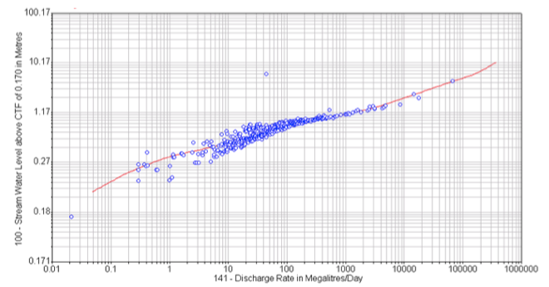
Figure 1 - example rating curve

Use Case
A number of use cases have been developed that involve a number of the IE contributors and water agencies within the countries involved. These use cases may be run in multiple example scenarios based on the water agencies’ requirements. For example, there will Australian instances of the exchange and a US based version.
- Use Case 1: Delivery of latest rating table
This use cases involves a central organization requesting the latest rating table from a water agency for the purposes of performing a conversion from one parameter to another. A number of exchange scenarios have been developed, involving the participating water agencies.
Features: Conversion groups, periods of rating applicability, rating tables.
Services: WFS, RESTful API
- Use Case 2: Exposing rating tables for analysis and educational purposes
This use case makes use of an online web client that allows general exploration, visualization and metadata description of rating tables and gaugings related to specific monitoring points. A prototype client to support this use case has been developed. A screen shot is shown in Figure 2. This client will allow visualization on the exposed web services, providing participants with a way to test their services and interact with the data. An example of this client running can be seen here: https://vimeo.com/70310422.
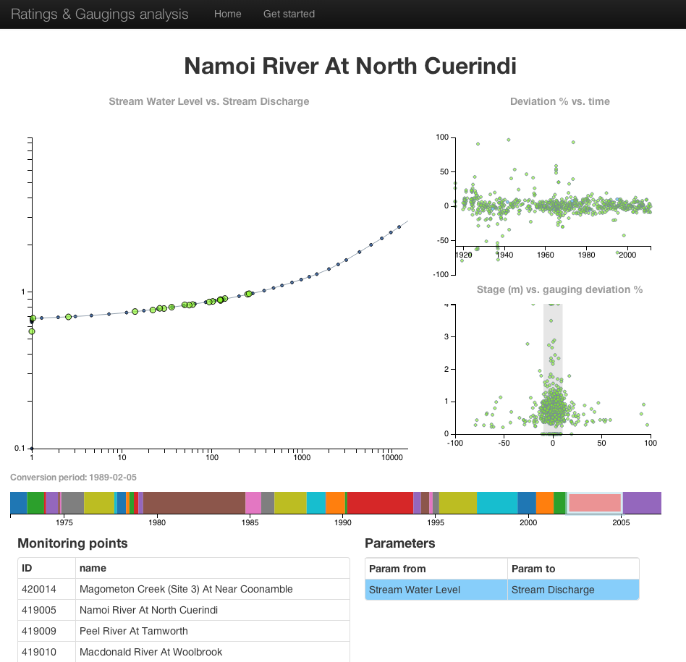
Figure 2 - prototype web client for rating table analysis
- Use Case 3: Retrieval of full rating history. This is a broader version of use case 1. It involves exchange of the full description of the rating curve history for specific monitoring points.

Experiments
The IE will attempt to address the following experiments:
- Experiment #1: The following client-server interaction describes a basic interaction:
- A client will request a list of all available rating groups for a specific site from a WFS or RESTful API .
- The WFS/REST API will respond with a WaterML2.0 part 2 encoding of rating groups.
- The client will then request all the available rating periods within a site/parameter-from/parameter-to combination.
- The WFS/REST API will respond with a WaterML2.0 part 2 encoding of the rating periods.
- The client will request a specific applicable rating table for a period.
- The WFS/REST API will respond with a WaterML2.0 part 2 encoding of the rating table.
- Experiment #2:
- A client will request all the available gauging observations for a specific site from a WFS/REST API.
- The WFS/REST API will respond with an encoding of the observations and their associated metadata, encoded in WaterML2.0 part 2.

TECHNICAL APPROACH
The Technical Approach for this Interoperability Experiment focuses on leveraging existing OGC Specifications and, as needed, developing Change Requests for these specifications. The following section describes the Technical Approach in detail.

Experimental Methodology
The methodology involves:
- Further detailing of the use-cases.
- Refinement and extension of existing UML models from WaterML2.0 part 2 discussion paper.
- Generation of GML-XML schemas from existing UML models.
- Investigation into use of JSON encoding from existing UML models.
- Development of proposed architecture/design for each use case/scenario. Includes specification for which services should be used and how.
- Defining and curating data sets required for each use case.
- Development of services (WFS/SOS/REST API) to support required encodings.
- Development of clients to display/retrieve required data per each use case description.
- Development of an engineering report.

RESTful API and JSON encoding
The prototype client described above was developed using a RESTful API based on the draft WaterML2.0 part 2 information model. The API encoded a JSON version of the model. This was done to enable rapid prototyping of a web client. Partners within the IE have expressed interest in the API and JSON encodings; these will be investigated further as part of the IE. Whether the JSON encoding and/or RESTful API will be part of the standardization of WaterML2.0 part 2 remains open.

Demonstration Planning
A demonstration period is proposed whereby the use cases will be made available for demonstration. At a minimum this will include presentation at the next annual Hydrology Domain Working Group meeting tentatively scheduled for August 2014.

Specification Development
The primary focus of this IE will be on the development and testing of WaterML2.0 part 2. This involves refining the core conceptual information model, through testing its encodings, and extension of the specification document that describes both the information model and encoding(s). The end result will be a draft candidate standard for Part 2, around which a Standards Working Group will be formed (or the existing WaterML2.0 SWG will take on).
A number of existing OGC services may be used in this IE. The list of specifications that may be affected includes:
- Web Feature Service (WFS)
- Sensor Observation Service (SOS)
In addition to these services, the IE is likely to explore the use of both RESTful service interfaces and JSON encodings of the WaterML2.0 part 2 model. Members of the RGSIE have identified this as a desirable technical approach.

Component Development
The following components will be developed concurrently by the responsible organization(s), to be completed by the execution end date.
Description | Implementer(s)
WaterML2.0 part 2 UML | CSIRO, Bureau of Meteorology
WaterML2.0 part 2 GML/XML Schemas | CSIRO, Bureau of Meteorology
WaterML2.0 part 2 JSON encoding specification (JSON Schema) | CSIRO
Client to retrieve latest rating tables | Bureau of Meteorology
WFS/SOS/RESTful API encoding WaterML2.0 part 2 | KISTERS, Aquatic Informatics, CSIRO, UK CEH, USGS
Web client for analytics use case | CSIRO
Use Case 1 | All
Use Case 2 | All
Engineering report | All

Other related services/clients that will be included:
Description | Sponsor / Implementor(s)
Rating table data | Bureau of Meteorology, Australian Water Agencies, USGS, UK CEH
Gauging observations data | Bureau of Meteorology, Australian Water Agencies, USGS, UK CEH
Cross section data | Bureau of Meteorology, Australian Water Agencies, USGS, UK CEH

Testing and Integration
- Evaluation against the describe use cases
- Evaluation of the effectiveness of WaterML2.0 part 2 to capture the core semantics of the rating tables, gauging observations and cross-sections across different organizations.
- Validation of the XML Schemas.
- Evaluation of the functionality of the implemented web services

DELIVERABLES
The documentation listed below will be considered the deliverable for the project.

Documentation
The following documentation will comprise the deliverables for the project:
- Candidate OGC Standard: WaterML2.0 part 2 – ratings, gaugings and cross-sections
- Engineering report describing the results of the IE.

Demonstration
- The developed documents will be made available on the HDWG Twiki and the OGC portal.
- A live demonstration of the services and clients will be shown at the annual Hydro DWG meeting, as well as at an appropriate OGC TC meeting.

SCHEDULE (Tentative)

Startup
Activity Plan submission: September 2013
Anticipated OGC Architecture Board approval: September 2013
Includes posting for 2 weeks for member comments
Execution
Planned kickoff date (execution start date): September-October 2013
Includes 30-day Participation Notification period
Design Oct-Dec 2013
Implementation Jan-Mar 2014
Testing and bug fixing Mar-July 2014
Planned end date: July 2014
Wrap-up and Reporting
Technology Demonstration May 2014
Final report submission June 2014

RESOURCE PLAN
The Initiative Manager will be Paul Sheahan, and the Initiative Technical Lead will be Peter Taylor. The OGC Initiative Facilitator will be TBD-OGC Staff.
The following resources will be available.
Staffing | Each initiating and participating organization will provide adequate staff resources to support their defined responsibilities for the duration of the RGSIE.
Hardware | Initiating organizations will provide hardware as needed to support the RGSIE.
Software | Initiating organizations will provide software as needed to support the RGSIE.
Other Resources | The participating water agencies will supply sufficient data to allow testing of the specified use cases.

REQUIREMENTS FOR PARTICIPATION

Participants can be Developers or Observers. Developers must be willing make a resource commitment to the development and evaluation of one or more of the components described in the Component Development section. Observers must be willing to provide feedback on some developed component, supply data for use within one of the use cases and/or can participate in all discussions.

INITIATOR ORGANIZATIONS – Contact Information

Organization Name | Commonwealth Scientific and Industrial Research Organisation
Business Contact | Name | David Lemon
 | Title | Research Stream Leader – Water Informatics
 | Street Address | Black Mountain Laboratories, Clunies Ross Street, Black  Mountain, ACT, 2601
 | Email Address | david.lemon@csiro.au
 | Phone | +61 2 6246 5724
 | Fax | NA
Technical Contact | Name | Peter Taylor
 | Title | Research Engineer
 | Street Address | CSIRO Castray Esplanade, Hobart TAS, 7000. Australia
 | Email Address | peter.taylor@csiro.au
 | Phone | +61 3 6232 5530
 | Fax | NA

Organization Name | Bureau of Meteorology
Business Contact | Name | Paul Sheahan
 | Title | Manager Water Data
 | Street Address | Bureau of Meteorology Canberra office - GPO Box 2334 -Canberra ACT 2601. Australia.
 | Email Address | p.sheahan@bom.gov.au
 | Phone | +61 2 6232 3530
 | Fax
Technical Contact | Name | Dominic Lowe
 | Title
 | Street Address | Bureau of Meteorology Canberra office - GPO Box 2334 -Canberra ACT 2601. Australia.
 | Email Address | D.Lowe@bom.gov.au
 | Phone | +61 2 6232 3530
 | Fax

Organization Name | United States Geological Survey (USGS)
Business Contact | Name | Nate Booth
 | Title
 | Street Address
 | Email Address | nlbooth@usgs.gov
 | Phone
 | Fax
Technical Contact | Name | David Briar
 | Title
 | Street Address
 | Email Address | dbriar@usgs.gov
 | Phone
 | Fax

Participant ORGANIZATIONS - Contact Information

Organization Name | Centre for Ecology and Hydrology (CEH)
Business Contact | Name | Matt Fry
 | Title | Senior Scientific Officer (Water Information Management)
 | Street Address | Maclean Building, Crowmarsh Gifford, Wallingford, UK
 | Email Address | mfry@ceh.ac.uk
 | Phone | +44 1491 692287
 | Fax
Technical Contact | Name | Matt Fry (as above)
 | Title
 | Street Address
 | Email Address
 | Phone
 | Fax

https://portal.opengeospatial.org/files/?artifact_id=54423
Graph extracted from http://www.water.nsw.gov.au/. Identifiers and site details removed.

